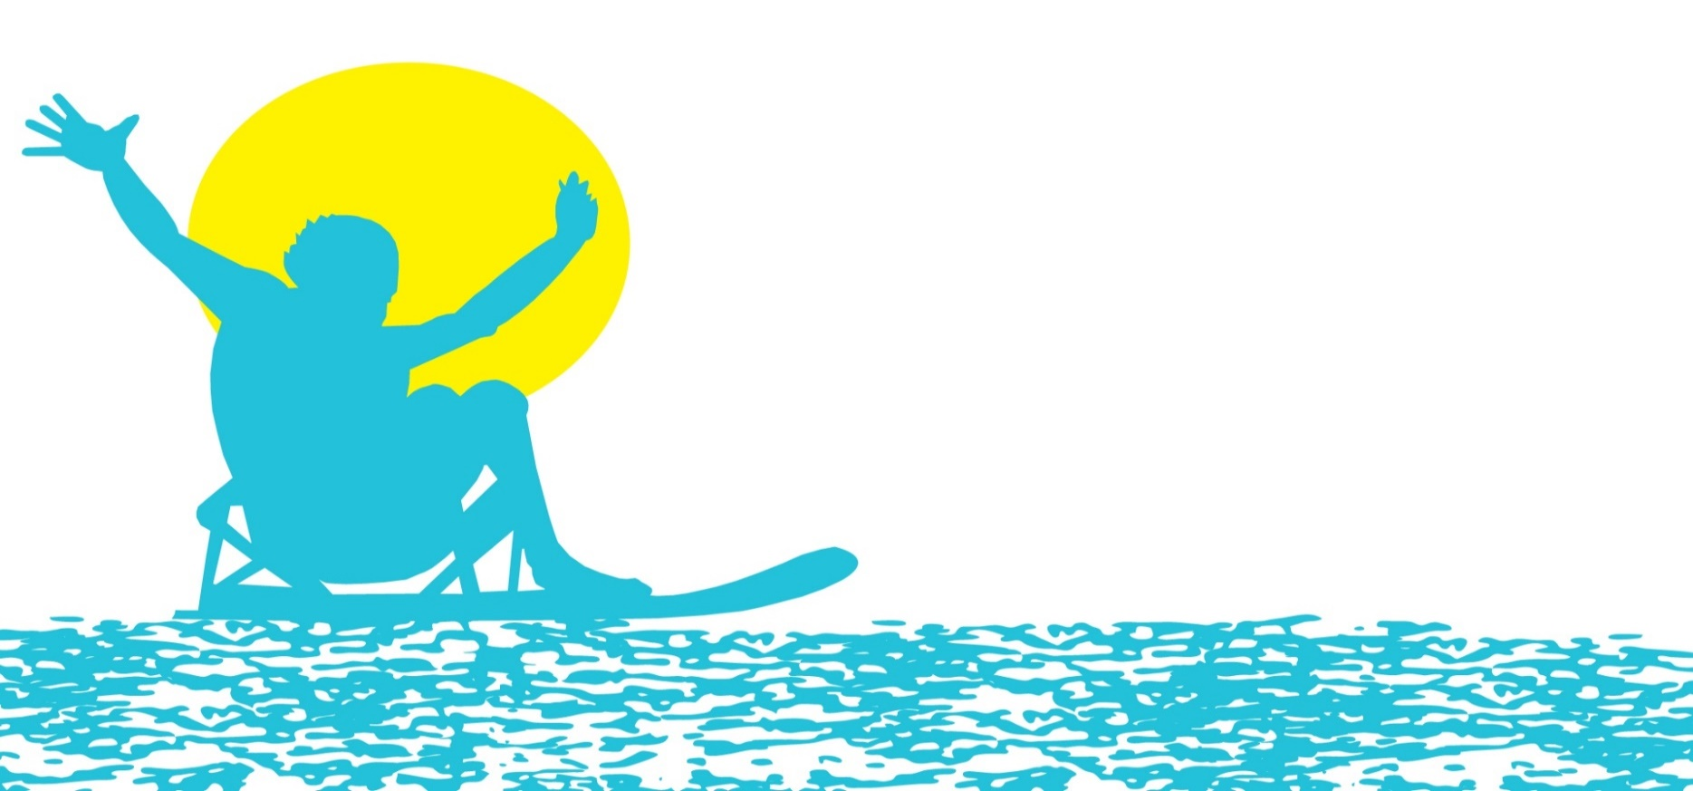
2022 DAY AT THE LAKE
SPONSORSHIP OPPORTUNITIES
Friday, July 15, 2022 | Crows Creek Landing, Smithville Lake
 | FUN IN THE SUN  $5,000 | ON THE WATER  $2,500 | COOLING OFF  $750
Inclusion in all media relations, as desired
Name and logo featured on digital and printed materials
“Reserved” volunteer spots for event participation * | 5 | 2
Name and logo featured on Midwest Adaptive Sports’ website, electronic communications and social media
Vendor table space at event (one six foot table and two chairs)
Name and logo featured on event t-shirt
Event t-shirts | 10 | 5 | 2

*Indicates all volunteers wishing to participate on a water team must complete a pre-event training on June 25, 2022.
Sponsorship Commitment Form
This commitment form must be returned by Friday, June 17, 2022 to be included on event signage, shirts and other promotional items.
Instructions
Please complete the form below. By submitting the form, you are committing to your chosen sponsorship level. Checks can be made payable to Midwest Adaptive Sports.
Your Information
Contact Name
Organization/Company
Address
City | State | Zip
Phone
Email

Sponsorship Level (please check one)
FUN IN THE SUN | ON THE WATER | COOLING OFF

Payment Information
Check Enclosed | Please Invoice | Please Charge My Card
Card Number |  |  | Exp
Signature
Billing Address
If paying by check, please send the check to:
Midwest Adaptive Sports
1800 Genessee Street, Suite 301
Kansas City, MO 64102

For more information about the event or sponsorship opportunities, please contact Gemma Zook at gzook@midwestadaptivesports.org or 816.804.6183.

Day at the Lake has provided countless
hours of freedom on the water for hundreds
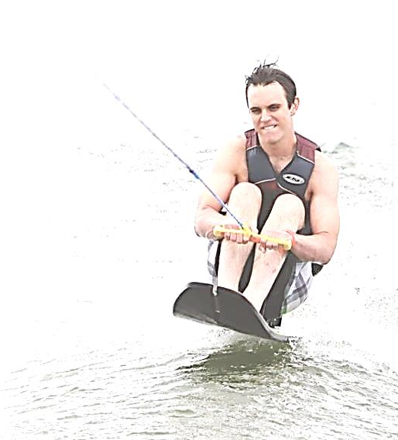
of individuals with spinal cord injury,
spinal cord disease, and amputation since 1993.

This event would not be possible without
the generosity of the Kansas City community
through the giving of their time and donations.

Thank you for considering sponsorship
opportunities for Day at the Lake.

